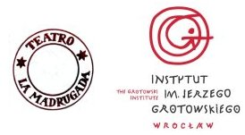

REGULA CONTRA REGULAM
Research Programme on Performing Arts

Directed by: Raul Iaiza and Teatro La Madrugada

OPEN SESSION in Brzezinka
8 to 15 of May 2011
for 13 actors and 2 directors

In collaboration and with the assistance from
THE GROTOWSKI INSTITUTE
Wrocław, Poland

APPLICATION FORM

I am applying as:
( ) actor
( ) director
[please mark with x one of the two]

FIRST NAME

FAMILY NAME

MALE/FEMALE

AGE

NATIONALITY

E-MAIL ADDRESS

PHONE NUMBER

Are you vegetarian or do you follow any special diet?

SPOKEN LANGUAGE/S

EDUCATION

PROFESSION

THEATRE EXPERIENCE

What is your motivation to participate in the seminar?

Have you already participated in work sessions from the Grotowski Institute’s programme or/and from Teatro La Madrugada’s? If yes, which ones and when?

HOW DID YOU COME TO KNOW ABOUT THE PROJECT REGULA CONTRA REGULAM?

